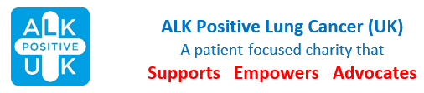
National ALK-positive LC Patient Conference
Radisson Red Hotel, Bath Road, Heathrow, UB7 0DU
Friday 26 September – Sunday 28 September

HCP Booking Form

Name:
email:
Telephone:
Home Address:
Job Title:
Place of Work:
Fully Residential: | Day Delegate:

Please return booking form as an attachment to an email to events@alkpositive.org.uk or post to ALK Positive UK, 1 Ethley Drive, Raglan , Monmouthshire, NP15 2FD.

We will invoice you for £150 fully residential or £75 day rate and request that payment be made no later than 31 August by bank transfer to ALK Positive Lung Cancer UK - Sort 55-70-34 and account 87815672, using the reference “Conference”.

Debra Montague
Chair ALK Positive UK
hello@alkpositive.org.uk

